**1. INTRODUCTION**

The web-based blood donor finder is a modern platform that connects blood donors with individuals in need of blood transfusions or donations. Utilizing the internet and advanced algorithms, this system provides real-time matching, promoting voluntary blood donation and ensuring swift assistance during critical medical emergencies. It enhances the availability of blood supplies and saves lives by leveraging technology to efficiently connect donors and recipients in a user-friendly and secure online environment.

**1.1 Scope**

The web-based blood donor finding system aims to efficiently connect blood donors with recipients, promoting voluntary blood donation and ensuring real-time matching during emergencies. Its user-friendly interface allows easy registration and communication between donors and recipients. The platform actively encourages more individuals to become regular donors, enhancing the availability and reliability of blood supplies for medical emergencies and treatments. By leveraging advanced algorithms and geolocation services, the system can match donors with specific blood types to nearby recipients in urgent need. Privacy and security measures are prioritized to maintain user trust and comply with data protection regulations. With a scope that can span from local to global, the web-based blood donor finding system has the potential to save lives and improve healthcare services worldwide.

**1.2 Existing System**

The Existing system of blood donor finding relied on manual records, blood banks, donor drives, word-of-mouth, and print media, lacking real-time matching and efficiency.

**The following are the drawbacks of the existing manual System:**

* Consumes lot of manpower for better results.
* Lack of data security.
* Retrieval of data takes lot of time.
* Time consuming.
* Percentage of accuracy is less.
* Traditional blood banking systems were developed by 1 or 2 perspectives.
* Tracking the database was complicated when the details are maintained manually.
* There was shortage and sometimes unavailability of rare blood groups due to less modules i.e. patient and donors.

**1.3 Proposed System**

The Proposed web-based blood donor finder system aims to connect blood donors and recipients through an online platform. Users can register as donors, providing essential information such as blood type and location. Recipients can create requests specifying their blood type and urgency. The system employs advanced algorithms and geolocation services to match donors with recipients in real-time, ensuring quick and efficient assistance during critical situations. The platform promotes voluntary blood donation, offers a user-friendly interface, and prioritizes privacy and security of user data, ultimately contributing to a reliable and accessible supply of blood for those in need.

**Here are some of the specific benefits of the application:**

* Time saving
* Accuracy
* Tracking of availability
* User friendliness

1. **SYSTEM ANALYSIS**

This System Analysis is closely related to [requirements analysis](http://en.wikipedia.org/wiki/Requirement_analysis). It is also "an explicit formal inquiry carried out to help someone (referred to as the decision maker) identify a better course of action and make a better decision than he might otherwise have made."This step involves [breaking down](http://en.wikipedia.org/wiki/Work_breakdown_structure) the system in different pieces to analyze the situation, analyzing project goals, breaking down what needs to be created and attempting to engage users so that definite requirements can be defined.

**2.1 Functional Requirement Specification**

The System after careful analysis has been identified to be present with the following forms:

* 1. **Login Form:**

This page is provided with two text fields namely ‘username’ and ‘password’, which must be filled and verified against the data already available in the database after clicking ‘Login’ button in order to move to the main interface page.

* 1. **Registration Form:**

This page contains all the necessary details of the user including ‘personal details’, ‘college details’, which has to be filled by the user to create an account in the website.

* 1. **Set Username and Password Form:**

This is the next page after Registration page, where user is allowed to set new username and password in order to login to the website.

**2.2 Performance Requirements**

Performance is measured in terms of the output provided by the application. Requirement specification plays an important part in the analysis of a system. Only when the requirement specifications are properly given, it is possible to design a system, which will fit into required environment.

The application can able to verify the login details against the details already available in the database and allow access only to the verified users. It can able to store the Registration form details in the database and also the created username and password details for the future logins. The application can be efficient to project the blood donor contact details in the tabular form after selecting a particular blood group.

**Here are some specific performance requirements for the application:**

* The application should be able to verify username and password in the database.
* The application should be able to store user registration information.
* The application should be able to store created username and password for future logins.
* The application should able to display the blood donor details after selecting a particular blood group.
* The application should be easy to use and navigate.
* The application should be secure and protect the privacy of users.

**2.3 Software Requirements**:

* **Operating System**: Microsoft Windows XP.
* **Front-End**: HTML, CSS

In our project, we used HTML and CSS to design all the pages include login, registration, create new username and password pages.

* **Technology**: Hypertext Preprocessor (PHP)

**PHP**: Hypertext Preprocessor is used for fetching the details from the database.

* **Back-End**: PHP, Mysql.

**PHP**: In our project php is used to validate the user’s data, to fetch the blood donor details.

**Database**: Database is used to set the structure and store the details of the user; username and password table, registration information table. In our project the database name is 21r11a0554.

Which contains those two mentioned tables.

* **Web-Server**: Xampp

**Xampp:** This is the web server which we have used for testing our project.

* **Editor Tool**: V S Code.

**V S Code**: It is the Code editor we used for writing, editing and debugging.

**2.4 Hardware Requirements**:

* Processor : Intel P-IV based system

**Processor:** We used intel processor to execute our instructions, performance and Multitasking facility.

* Hard-Disk or SSD : 40 GB or more.

**Hard-Disk:** To store all the project files

* RAM : 2 GB or more

**RAM:** To run and store the data of our project.

**3.SYSTEM DESIGN**

Systems design is the process of defining the architecture, components, modules, interfaces, and [data](http://en.wikipedia.org/wiki/Data) for a [system](http://en.wikipedia.org/wiki/System) to satisfy specified [requirements](http://en.wikipedia.org/wiki/Requirement). . One could see it as the application of [systems theory](http://en.wikipedia.org/wiki/Systems_theory) to [product development](http://en.wikipedia.org/wiki/Product_development). [Object-oriented analysis and design](http://en.wikipedia.org/wiki/Object-oriented_analysis_and_design) methods are becoming the most widely used methods for computer systems design.

**3.1 Architectural Design**

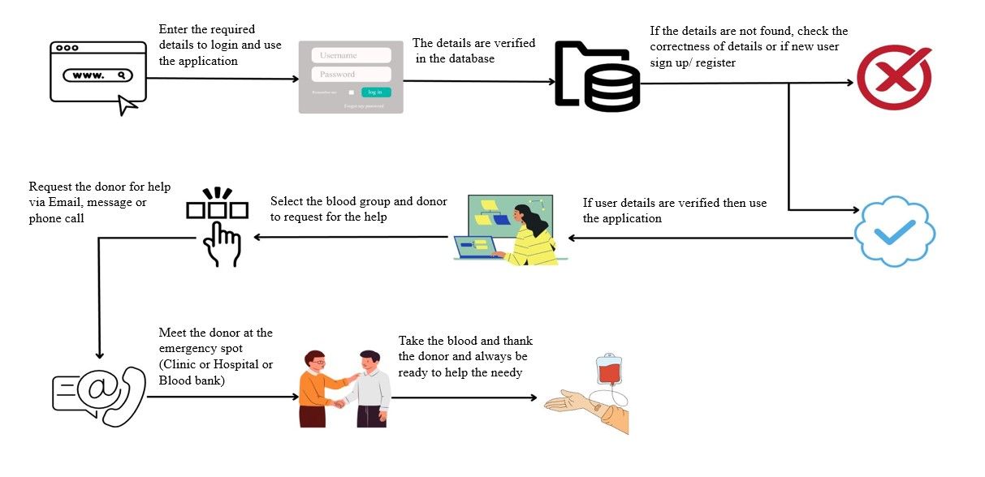

**Fig 3.1 Architectural Design**

**Fig 3.1** The architecture diagram shows the flow of pages in the application. At first when user opens the website the user will see a login page, where the user is supposed to enter the username and password fields to login. The new is redirected to the fill the registration form and has to create new username and password to use the application. After filling the correct login details the user can select the required blood group via radio buttons provided and can the see the details of the donor details of the selected blood group.

**3.2 Modules:**

**1.User Registration and Authentication Module:** This module allows users to create accounts and log in to the system. It manages user credentials, verifies user identity, and provides secure access to the system's features.

**2.Donor Profile Management Module:** Users who wish to donate blood can create and manage their profiles in this module. Donors can provide essential information such as blood type, contact details, location, availability, and any relevant medical history.

**3.Recipient Request Module:** This module enables individuals or organizations in need of blood to make requests for blood donors. Recipients can submit requests, specifying the required blood type, quantity, and location.

**4.Search and Matching Module:** The core functionality of the system lies in this module. It allows users to search for blood donors based on specific criteria, such as blood type, location, and availability. The module matches the donors with the recipient's requirements and presents relevant results.

**5.Messaging and Communication** Module: Once a match is made, this module facilitates communication between donors and recipients. It may include chat or messaging features to help donors and recipients coordinate the blood donation process.

**6.Admin Panel:** This module is accessible only to administrators or moderators. It allows them to manage user accounts, handle reported issues, and ensure the smooth functioning of the system.

**7. Privacy and Security Module:** This module ensures the security of user data and implements privacy measures to protect sensitive information.

**4. SYSTEM IMPLEMENTATION**

The implementation stage of any project is a true display of the defining moments that make a project a success or a failure. The implementation stage is defined as the system or system modifications being installed and made operational in a production environment. The phase is initiated after the system has been tested and accepted by the user. This phase continues until the system is operating in production in accordance with the defined user requirements.

**4.1 Algorithm**

Algorithm Blood-donor

{

While (user)

{

if (user)

->enter username

->enter password

if(valid)

{

-> select blood group

-> on submit "display blood donor information"

}

else if (not valid)

print (Invalid credentials)

}

else

{

->print (register if new user)

->enter the data

if (error)

->check the details before submit

else

->on submit “move to create username password page”

}

->enter new username

->enter new password

->enter new password again

{

if (correct)

->on submit “go to login page”

else

->print (“password, confirm password are not same”)

}

}

**5. OUTPUT SCREENS**

Output Screens of various functionalities in our application are shown over here along with the description.

**5.1 Index-Page:**

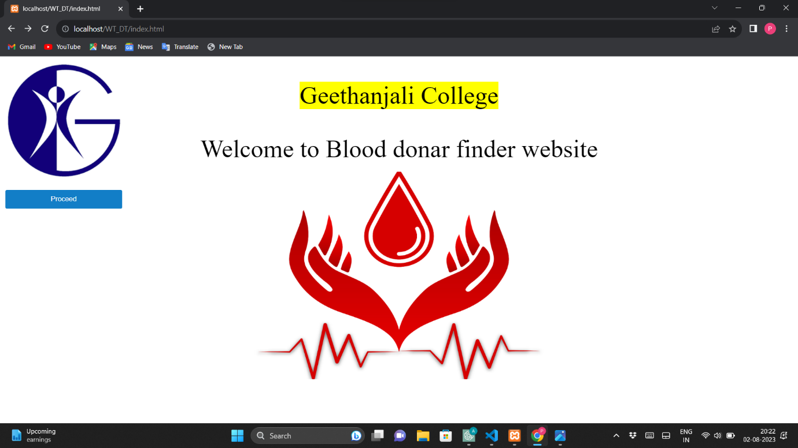

**fig 5.1.1 index page**

**5.1.1** This is the starting page of our application. This page contains our college name in the top center with highlighted text and below that the name of the application with the related image. The top left of the page contains our college logo and one proceed button below it, such that on clicking it the user move to the next page which is login page.

🡪 The index page of a web application is the main or home page where users land when they visit the website. It includes the application's logo, navigation menu, introduction, CTA button, visual elements, features, testimonials, contact information, and footer. The index page sets the tone and first impression, encouraging users to explore further and take desired actions within the application.

**5.2 Login-Page:**

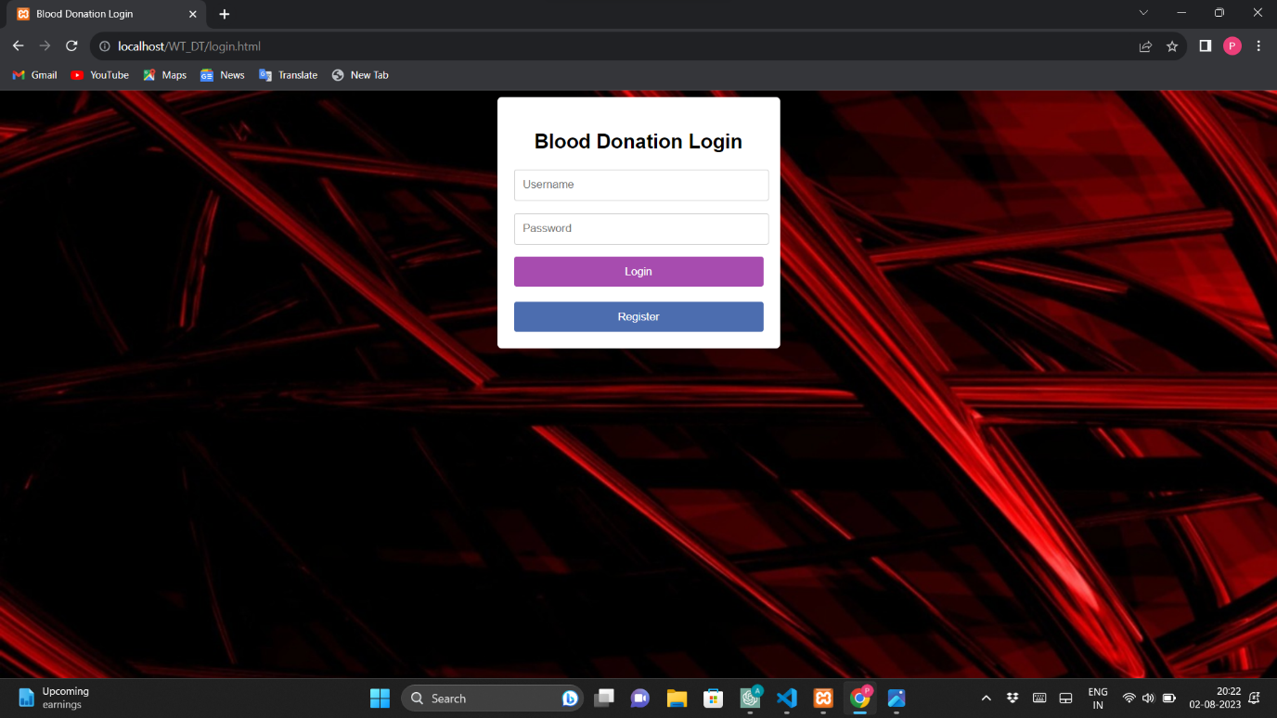

**fig 5.2.1 login page**

**5.2.1** This is the important page in any web application or mobile application to use the application securely.

In our web application also login page plays a key to ensure only registered users to use the application. This maintains the privacy and security.

🡪 The login page is needed for user authentication, ensuring privacy, security, access control, and personalized experiences. It enables auditing, user management, and prevents unauthorized access, enhancing the overall application security and user experience.



**fig 5.2.2 Error message for invalid login details**

**5.2.2** If login details are incorrect, the user will get a ‘login failed’ message on the next page and new user to register to use the application.

🡪 The error message for incorrect login details should be clear and user-friendly while not disclosing specific reasons for the login failure to prevent potential security breaches. A suitable error message could be:

"Invalid login credentials. Please check your username/email and password and try again."

This message informs the user that the login attempt was unsuccessful without revealing whether the issue is related to the username/email or password. It encourages the user to recheck their input and attempt to log in again. Implementing CAPTCHA or other security measures after repeated failed login attempts can also help protect against brute-force attacks.

**5.3 Registration-Page**

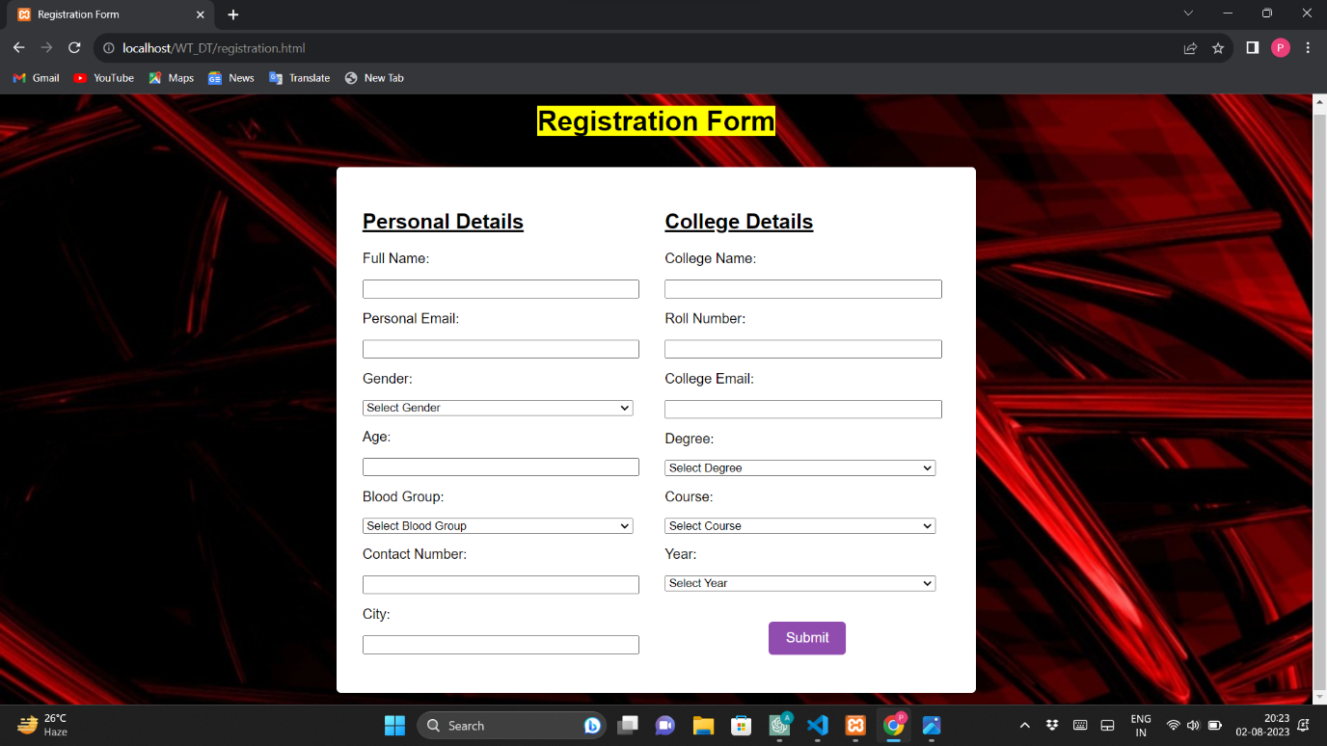

**fig 5.3.1 Registration Page**

**5.3.1** On this page the user is provided with the form to fill all the mandatory details with necessary validations to register and use the application. After clicking submit on filling all the details, the user data is stored in the database and the user is redirected to the next page, which is create new username and password page.

In this page, three validations are performed on filling the form they are:

1.Age validation

2.Contact number validation

3.College email validation

🡪 The registration page is needed to create user accounts, provide personalized experiences, collect user data, ensure security, manage accounts, and enable communication and notifications. It fosters user engagement, loyalty, and access to support services.

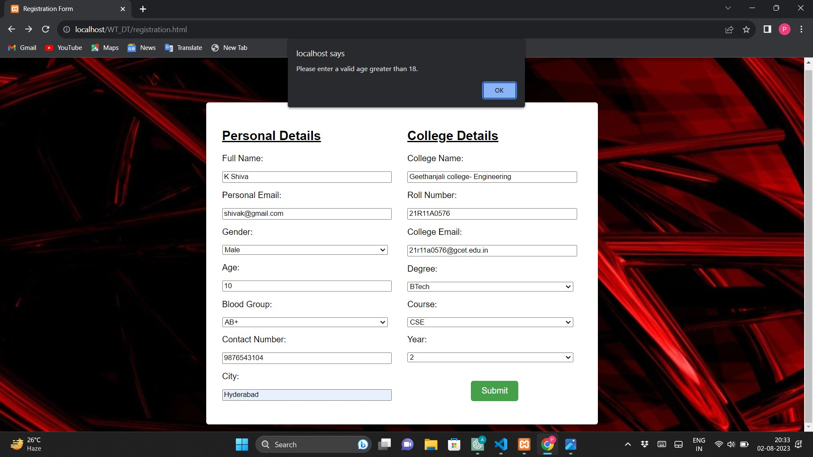

**fig 5.3.2 Age validation alert message**

**5.3.2** The age of the user must be greater than 18 years to use the application. Here, what we want to specify is the people who are coming under the age 18 years are not allowed to donate the blood. As, the people under the age 18 years are monors.

🡪 The age criteria for blood donation can vary depending on the country and specific blood donation guidelines. In many countries, the minimum age to donate blood is usually 17 or 18 years old. Some places may allow 16-year-olds to donate blood with parental consent.

On the other hand, there is an upper age limit for blood donation in some regions. Typically, donors need to be below the age of 65 or 70, but this can vary. Some countries may have different age limits for first-time donors and regular repeat donors.

It's essential to check with the local blood donation centers or organizations to know the specific age requirements and eligibility criteria for donating blood in your area. They will provide accurate and up-to-date information on age restrictions and other factors that might affect eligibility, such as health conditions, travel history, and recent vaccinations.

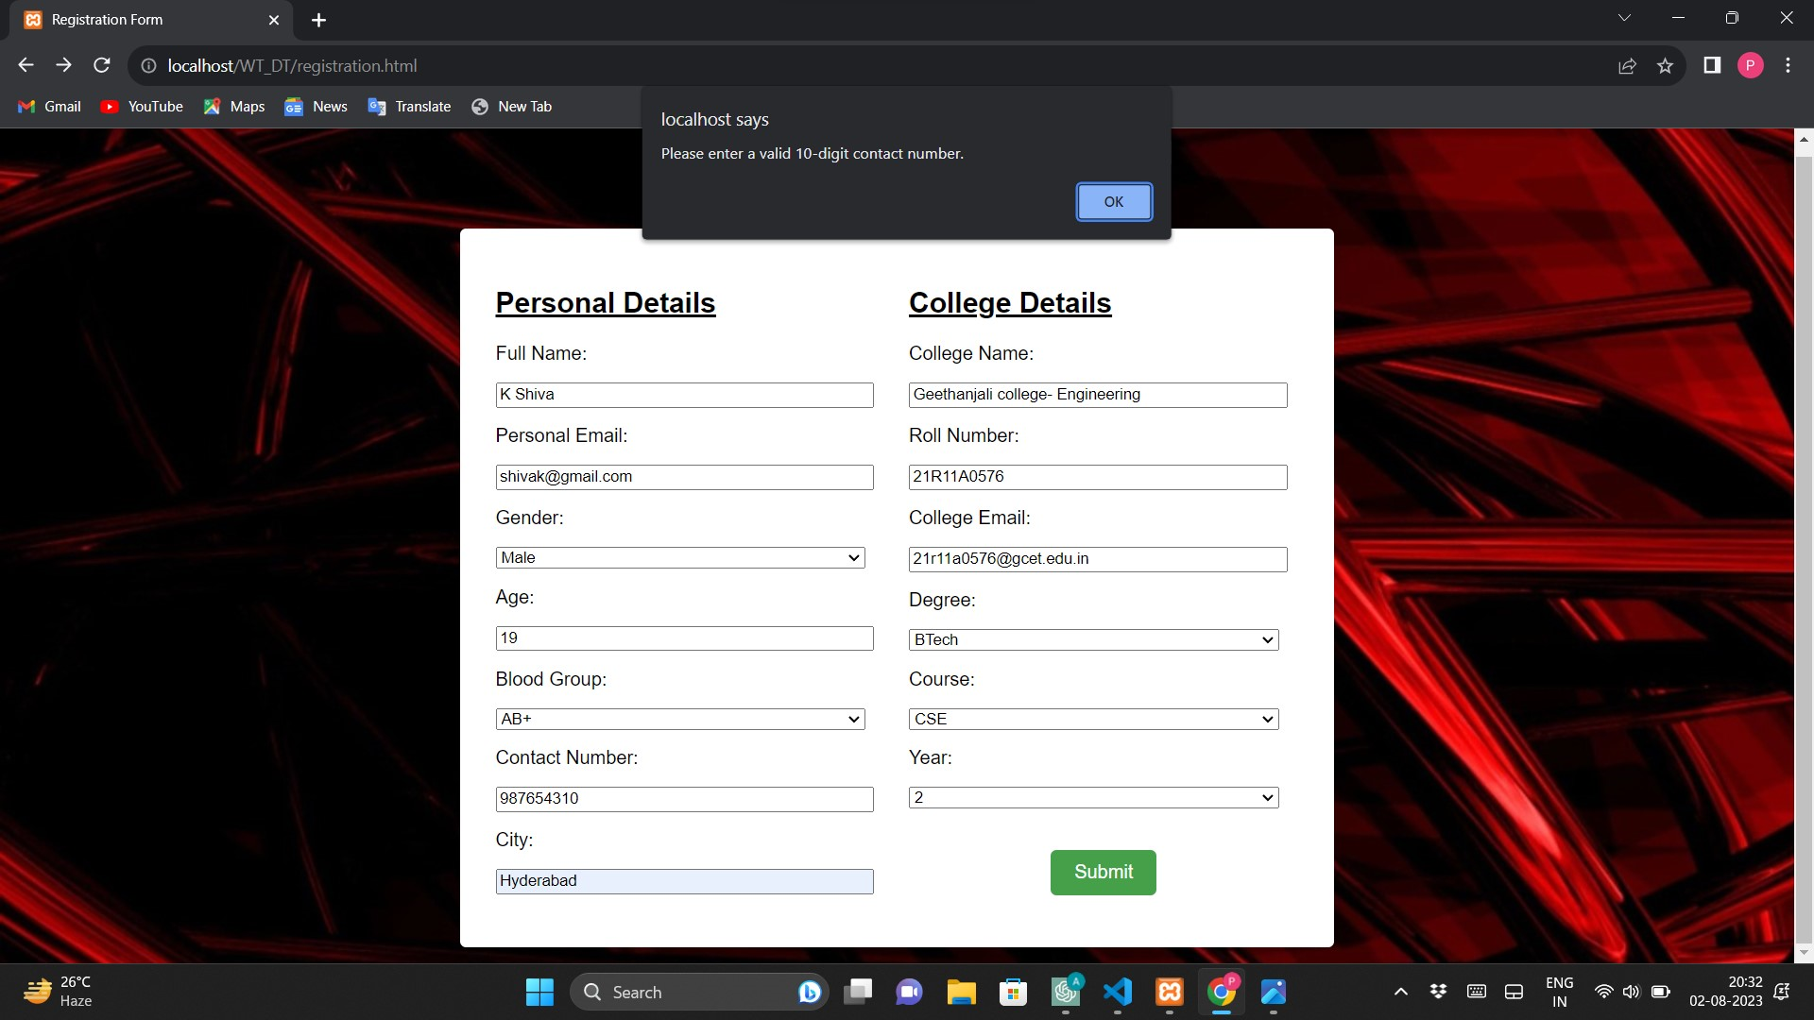

**fig 5.3.3 Contact validation alert message**

**5.3.3** The contact number must and should contain 10 digits, because it is the main tool to request the blood donor for our need.

🡪 Indian mobile numbers usually contain 10 digits. The format of an Indian mobile number is typically "XXXXXXXXXX," where "X" represents a digit from 0 to 9. The first digit is the mobile number's operator code, which can be used to identify the telecom service provider. The following digits form the unique subscriber number. Keep in mind that mobile number formats and regulations can vary slightly for specific regions or mobile service providers in India.

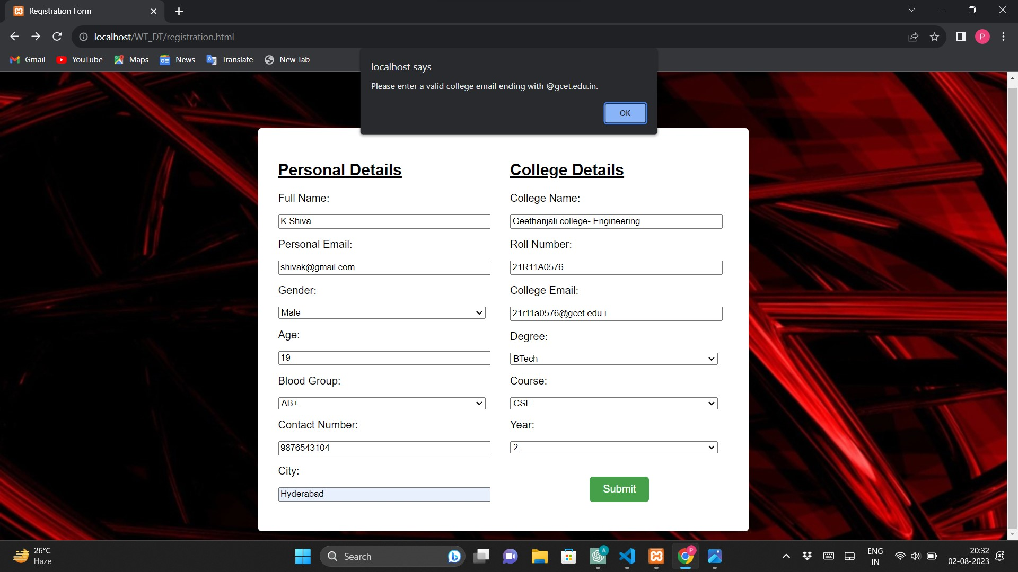

**fig 5.3.4 College email validation alert message**

**5.3.4** In our college every student and teacher are provided with college official mail id’s. For students the college mail is their roll number plus our college default domain. And for teachers the college mail is there name plus our college default domain. In both the cases the domain is common. So, here we kept a validation that the college email must end with the domain ‘@gcet.edu.in’ which is our college offical domain for the mail id’s.

🡪 Different domains for college mail IDs are used for branding, organization, security, and customization purposes. It allows colleges to create a distinct identity, segregate email accounts based on roles, implement tailored security measures, have more control over account management, and customize their email systems to suit specific needs.

**5.4 Set Username Password Page**

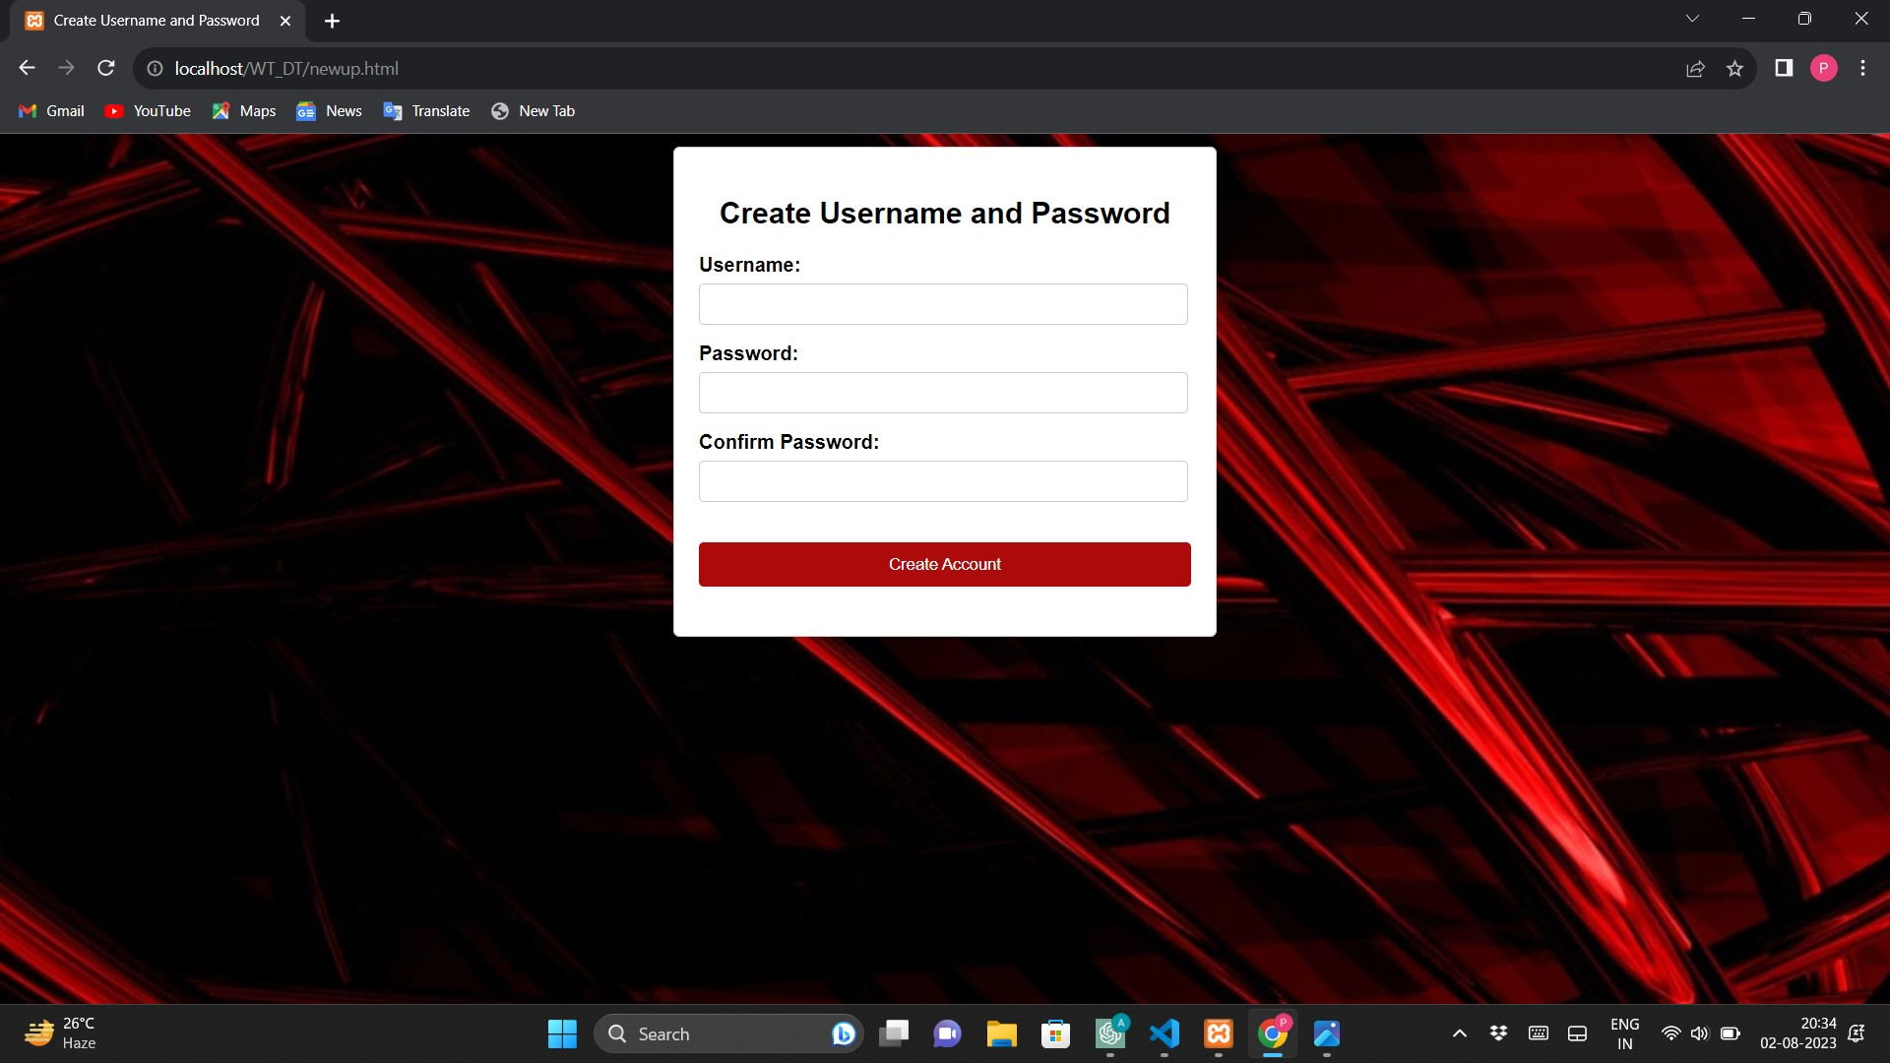

**5.4.1 Set username password page**

**5.4.1** On this page, after filling the registration details, the user is required to set a new username and password to use the application for future logins.

🡪 The "Set Username and Password" page is where users finalize their registration by choosing a unique username and password for their account. It includes fields for username, password, and password confirmation, along with error handling and password strength indicators. This step ensures personalized identification and account security within the application.

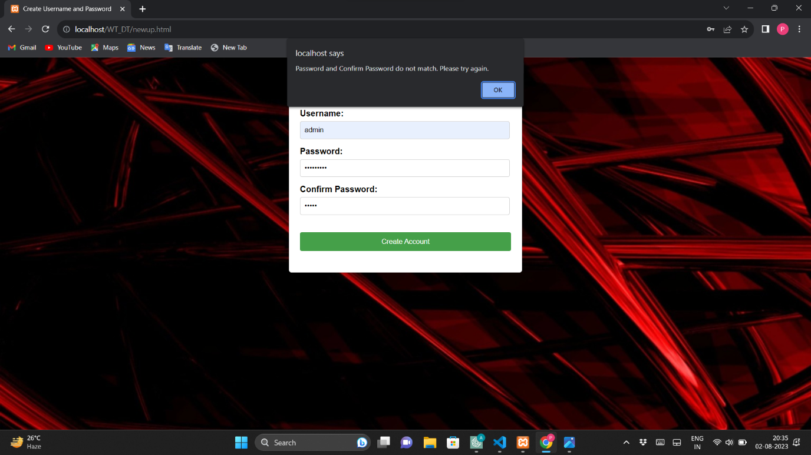

**fig 5.4.2 Alert for password mismatch**

**5.4.2** This alert message is displayed when password and confirm password are not same.

🡪 The "Password and Confirm Password mismatch" alert message is needed to inform users when they attempt to set a new password and mistakenly enter different values in the "Password" and "Confirm Password" fields. This message ensures that users are aware of the error and prompts them to re-enter their chosen password accurately. It helps prevent the creation of accounts with incorrect passwords and ensures that users can successfully set their desired password to access the application's features securely.

**5.5 Main User Interface**

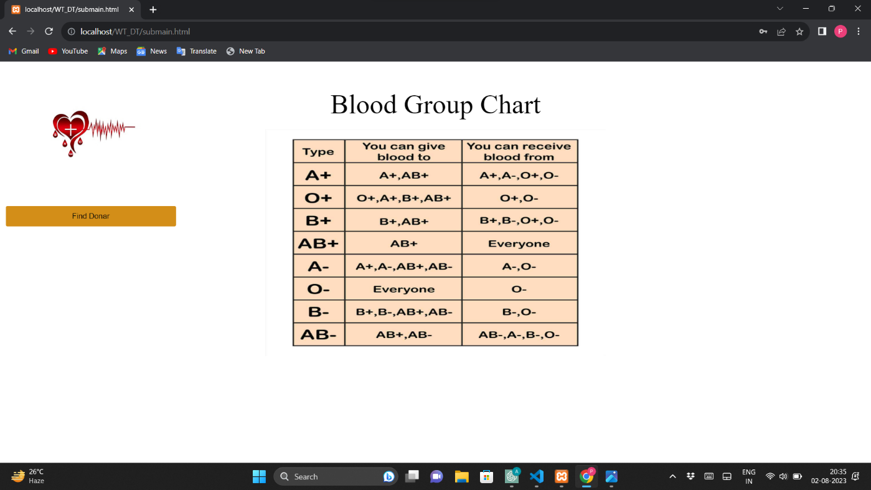

**fig 5.5.1 Main user interface**

**5.5.1** This page contains simple blood group chart, which lets user to know about which blood group can be accepted and donated.

🡪 The main page of a website, also known as the homepage or landing page, is the initial page users see when they visit the site. It provides an overview of the website's content, branding, and offerings. Typically, it includes a logo, navigation menu, hero section with a catchy headline, CTA button, key features or services, testimonials, about us section, contact information, and footer. The main page plays a crucial role in creating a positive first impression, guiding users to explore the site further, and communicating the website's value proposition.

**5.6 Select blood group page**

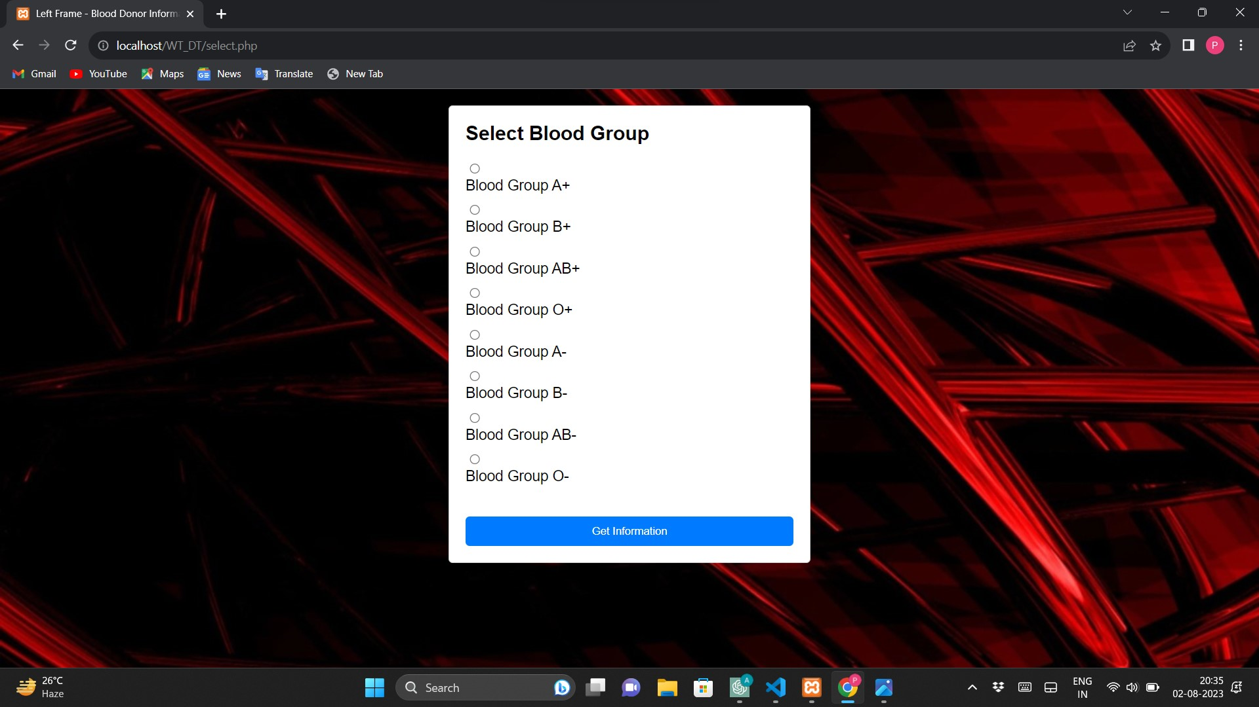

**fig 5.6.1 Select blood group page**

**5.6.1** In this page the user is allow to click one of the radio buttons named with all the blood groups available as per their requirement.

🡪 The "Blood Group Selection Page" is a crucial component of a blood donor finding system or blood donation platform. On this page, individuals or medical facilities can specify the required blood group for patients in need of blood transfusions or medical treatments. Users can select the desired blood group from a dropdown menu or list of available options. The page may also include additional fields for the quantity of blood needed, location, and contact information. By providing a streamlined and user-friendly interface to select the required blood group, this page facilitates efficient matching between blood donors and recipients. It plays a vital role in connecting potential donors with those in need, ultimately contributing to saving lives and enhancing the accessibility of blood donation services.

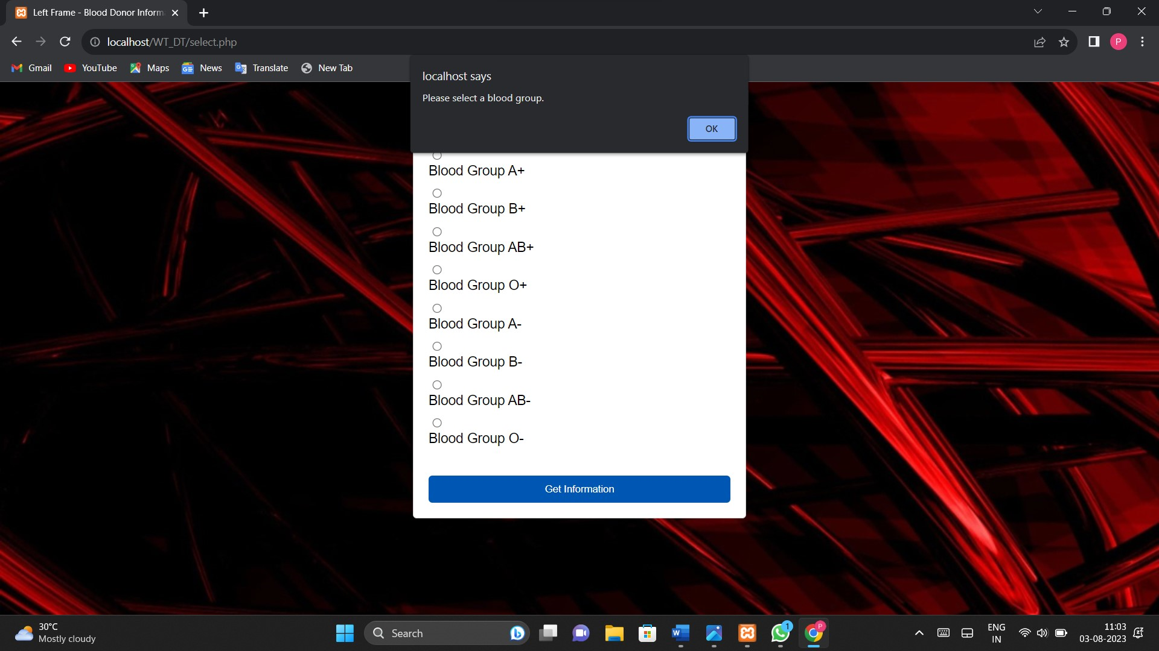

**fig 5.6.2 Alert for not selecting the option**

**5.6.2** If no blood group is selected, the user gets an alert the select the blood group.

🡪 The alert message "Please select a blood group from the dropdown menu before proceeding. This field is mandatory for submitting the request." is necessary to ensure that users provide essential information when making a blood donation request. Without specifying the required blood group, the system won't be able to accurately match donors with recipients, leading to inefficient and ineffective blood donation coordination.

By prompting users to select a blood group before proceeding, the alert message helps prevent incomplete or erroneous requests and ensures that the blood donation process is more efficient and successful. It also guides users on the necessary information they need to provide to find suitable donors, ultimately enhancing the chances of finding matching blood donors in critical situations.

**5.7 Results Page**

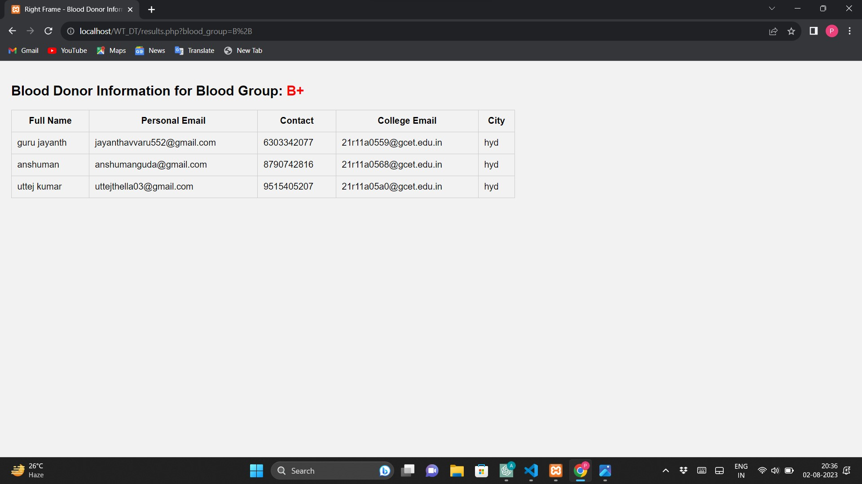

**fig 5.7.1 Donor details exist**

**5.7.1** If the donor details exist in the database, then his contact details are displayed in this page in the tabular form for the selected blood group.

🡪 The "Blood Donor Details Displaying Page" is a critical web page in a blood donor finding system. It presents a list of potential blood donors with essential information such as names, blood groups, locations, and availability. Contact details like phone numbers or email addresses are provided to enable recipients to reach out for blood donations. The page helps recipients find suitable donors quickly and efficiently, ultimately contributing to life-saving blood transfusions. With filters to refine the list based on location or blood group, this user-friendly page streamlines the process of connecting recipients with donors, enhancing the chances of finding timely blood donations and saving lives.

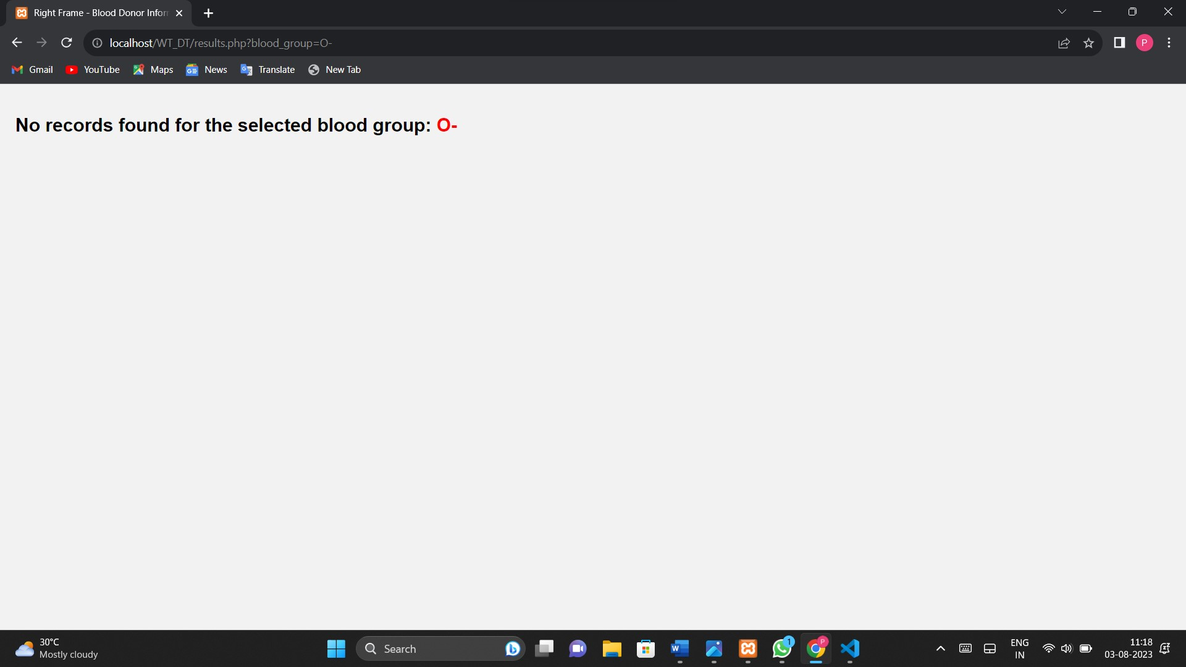

**fig 5.7.2 Donor details doesn’t exist**

**5.2.2** If the donor details do not exist in the database, the user will get the message that ‘donor details are not found for the selected blood group’.

🡪 If a donor doesn't exist for a specific blood group, the "Blood Donor Details Displaying Page" can display a message such as:

"No donors currently available for this blood group. We recommend reaching out to nearby blood banks or medical facilities for urgent blood requirements."

This message informs the recipient that no suitable donors are currently listed in the system for the required blood group. It suggests alternative actions, like checking with local blood banks or hospitals, to find potential donors. It's important to provide prompt and useful information in such cases to ensure recipients can explore other avenues to meet their urgent blood needs.

**6. CONCLUSION AND FUTURE SCOPE**

**Conclusion**

The web-based blood donor finder is a valuable and life-saving tool that effectively connects blood donors with individuals in need of blood donations. Through its user-friendly interface and advanced search algorithms, it has greatly simplified the process of finding compatible blood donors, reducing the time and effort required to secure life-saving blood donations.

By leveraging the power of technology and the internet, the blood donor finder has significantly improved access to blood donors, particularly during emergencies and critical situations. It has proven to be an essential resource for hospitals, medical facilities, and individuals seeking urgent blood transfusions.

Furthermore, the web-based platform has played a crucial role in increasing awareness about blood donation and fostering a sense of community among potential donors. The convenience of the system has encouraged more people to register as donors, creating a larger pool of potential donors and ensuring a more reliable supply of blood.

Overall, the web-based blood donor finder has made a significant impact on the healthcare industry, saving lives, and positively influencing the blood donation ecosystem. Its potential to connect donors and recipients efficiently makes it a vital tool in the ongoing efforts to address blood shortages and improve access to life-saving transfusions.

**Future Scope**

The future scope of a web-based blood donor finding system holds great promise in revolutionizing the blood donation landscape. With advancements in technology and healthcare, these systems are poised to bring about significant improvements in donor recruitment, blood inventory management, and overall efficiency.

One of the key developments lies in real-time blood inventory management. By integrating with various blood banks and donation centers, the system can provide up-to-date information on blood stocks and ensure that the demand for different blood types and components is met effectively. This can prevent shortages and streamline the allocation of resources where they are needed the most.

Artificial intelligence and predictive analytics will play a crucial role in the future of blood donor finding systems. By analyzing historical data and identifying patterns, AI algorithms can predict blood demand, enabling proactive planning and preparation. This foresight can be especially valuable during emergencies and disasters when the need for blood is critical.

Geolocation services and emergency alerts will enhance the system's ability to reach potential donors quickly. When emergencies arise, the system can send alerts to donors in the vicinity, mobilizing them to respond promptly and save lives.

Mobile applications and wearable devices will extend the reach of the system, making it more accessible to a broader audience. With dedicated apps, donors can schedule appointments, receive reminders, and access essential information on the go, increasing donor engagement and retention.

Blockchain technology will ensure data security and transparency in the blood donation process. By creating an immutable record of transactions, the system can build trust among donors and recipients, as well as reduce the risk of fraudulent activities.

Incorporating telemedicine will open up new opportunities for remote blood donations, allowing donors to contribute from remote or underserved areas with the guidance of healthcare professionals.

Overall, a future-oriented web-based blood donor finding system will rely on innovation, collaboration, and continuous improvement through data analytics. By leveraging these advancements, such systems can play a pivotal role in saving lives, meeting blood supply demands, and making a positive impact on global healthcare.

**BIBLIOGRAPHY**

[1] <https://www.canva.com>

[2] https://www.creately.com

[3] [*www.chatgpt.com*](http://www.chatgpt.com)

[4] [*www.google.com*](http://www.google.com)

[5] <https://tailwindcss.com/>

[6] https://getbootstrap.com/

**REFERENCES**

* https://nevonprojects.com/web-based-blood-donation-management-system-project/
* <https://www.eraktkosh.in/BLDAHIMS/bloodbank/transactions/bbpublicindex.html>
* <https://iopscience.iop.org/article/10.1088/1742-6596/1447/1/012001>
* <https://www.ijraset.com/research-paper/web-based-blood-bank-management-system-for-efficient-blood-donation-and-distribution>
* <https://creately.com/diagram/example/i157n331/web-based-blood-donation-system-classic>
* <https://projectsgeek.com/2013/10/online-blood-donation-management-system-project.html>
* https://www.slideshare.net/Rprasad1/blood-donation-ppt-67420666